**Leader Overview**

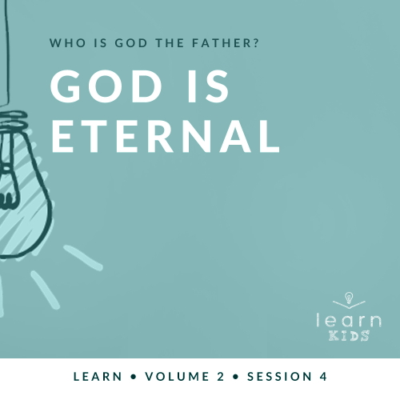

**Who is God the Father?**

*God the Father chose to reveal who He is throughout His Word. A robust picture of God can be seen by looking at His interactions with men and women like us. Since people first sinned in* [*Genesis 3*](https://ref.ly/logosref/Bible.Ge3)*, every generation has had to connect with our invisible God for themselves. Through these sessions about God, you have the opportunity to pass on this life-changing relationship to kids*.

**God Is Eternal**

*In the Bible, God reveals himself as the eternal God. He is the Beginning and the End. When He sent Moses on a dangerous and important mission to save God’s people in Egypt, God promised that He would go with Moses. No matter what situation we face, He is always with us*.

**Bible Lesson**

God States His Eternal Name

[Exodus 3:1–15](https://ref.ly/logosref/Bible.Ex3.1-15)

**Faith Fact**

My God is always with me.

**Faith Verse**

[Isaiah 55:8](https://ref.ly/logosref/Bible.Is55.8) (NLT)

“My thoughts are nothing like your thoughts,” says the Lord. “And my ways are far beyond anything you could imagine.”

**Preparing for the Session**

**Leader Preparation Time: 20–25 Minutes**

|  |
| --- |
| ***You Will Need***  ***Large Group***   * *Bible* * *Worship songs (Song suggestions: “Your Love Awakens Me” by Phil Wickham; “Goodness of God” by Bethel Music; “Move” by Jesus Culture; “Faithful Now” by Vertical Worship)* * *For groups not using a phone or tablet only, add:*   *• Projector or TV*  *• Laptop*  *•* ***Faith Fact Slide***  *•* ***Faith Verse Video*** *or* ***Slide***  *•* ***Bible Lesson Video***  *•* ***Teaching Point Slides 1–3***  *• Dry erase white board or poster board*  *• Dry erase marker or permanent marker*  *• Eraser*  ***Small Group***   * *Bibles for kids in your group to share* * *Timer* * *Small prize, for fastest kid* * ***Small Group Activity Page****, one per kid* * *Markers or crayons*   *To access session content from a computer, visit:*  [*BibleEngagementProject.com/downloads*](https://bibleengagementproject.com/Downloads) |
| ***Getting Ready***  ***Large Group***   * *Download videos and slides if needed.* * *Select worship song(s) and have them ready to play.* * *Read the Bible Lesson Scripture to prepare for teaching time.*   ***Small Group***   * *Print copies of the* ***Small Group Activity Page****, one per kid.*   ***First time leading* Learn *for Kids? Check out the*** [***Facilitator Guide***](https://0b769b0ed3569ef9d18b-f88d8272f61086866d50d048b43ef630.ssl.cf2.rackcdn.com/sites/biblengagementproject/Listen_Facilitator_Guide.pdf)***.*** |

**Large Group**

**30 Minutes**

*See what’s needed at the beginning of the session.*

**Introduction**

We’ve learned so much about God the Father. Who can tell me the big question we’ve been answering about Him? *(Allow responses.)* I’m so glad you have all been listening. We are answering the big question: Who is God the Father? We’ve learned that He is the one true God, that He is always in control, and that He cares about us.

Today, we’ll learn that God the Father is eternal. What does that mean? *(Allow responses.)* It means that God has been around forever. He is, He was, and He always will be. If that makes your head spin, that’s okay. It’s impossible for us to fully understand God’s existence because we aren’t like Him. We were all born at a specific time and place.

**Faith Fact**

Even more amazing than God being eternal is that He loves you and me. He loves us so much that He is always here. He’s everywhere at once. To help us remember that, today’s Faith Fact is **My God is always with me**.

• *Show the* ***Faith Fact Slide***.



Can you say that with me? **My God is always with me.** Now put your hands over your heart and say it again. **My God is always with me.** Great job!

**Game**

**Always, Sometimes, or Never?**

When someone or something is always with us, we might not even notice it very often. Think about the air we’re breathing. Do you think about the air always being here? *(Group response)* I never really think about it. I take it for granted that I’ll always be able to breathe.

There are so many things to do, eat, and enjoy in life. For example, I always love *(say one thing you love to do.)* However, I never want to *(say one thing you don’t like doing).* There are some things I don’t mind doing some of the time, but it depends on my mood or who I’m with.

Today’s game is Always, Sometimes, or Never. I’ll read an option of something to do, eat, or enjoy. You’ll decide if you always love to do it, sometimes enjoy it, or never ever want to do it. Here’s what you’ll do.

• *Optional: If you have the space, change the instructions below. Make one side of the room “Always,” the other side “Never,” and “Sometimes” in the center. Let kids run to the spot of their answer*.

If you would always love to do it, put your hands up in the air. If you sometimes enjoy it shrug your shoulders and hold your arms at your side. If you never ever want to do it, cross your arms over your chest.

• *Demonstrate all the options. Then have kids do them with you a couple times*.

Now, let’s get started. Do you always, sometimes, or never enjoy:

• *Playing in the rain*

• *Taking a long hike*

• *Eating a picnic at the park*

• *Riding roller coasters*

• *Waking up early in the morning*

• *Staying up super late at night*

• *Hanging out with friends*

• *Going to church*

• *Eating healthy food*

• *Eating your favorite junk food*

• *Speaking in front of people*

• *Doing homework*

• *Taking a test*

• *Meeting new people*

• *Starting something new*

• *Making videos*

• *Watching videos other people made*

• *Twirling in a circle with other people around*

• *Going shopping*

Great job, everyone!

**Worship**

I may not always love doing some of those things, but I always love worshipping God. I hope you do, too. Let’s worship God today like He is right here in the room with us because He is. Let’s sing to Him now.

• *Lead the kids in singing one or two praise songs. See suggestions at the beginning of the session*.

**Bible Lesson**

God always loves it when we take the time to worship Him. He also loves it when we take the time to learn more about Him. It’s time to open up our Bible and learn something new about God the Father. But first let’s pray and invite God into our Bible time today.

**Prayer**

|  |
| --- |
| *Dear God, thank You for always being there for us. Help us to remember that You are here. Help us choose to spend even more time with You. Amen.* |

**Video Intro**

Before we look at the Bible story, let’s watch this video.

• *Play* ***Bible Lesson Video***.

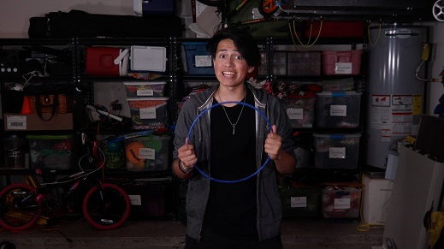

**Bible Story**

**God States His Eternal Name**

That was a fun intro. We don’t hear much about God speaking directly to someone in an audible voice, but that’s exactly what He did in today’s Bible story. Let’s find out what happened. If you want to follow along, open your Bible to [Exodus 3:1–15](https://ref.ly/logosref/Bible.Ex3.1-15).

• *Read the Bible story aloud to the group*.

• *In order to keep Large Group time moving along, we don’t recommend having the kids read*.

• *Optional: Remind the kids to mark this place with their Bible Bookmark, so they can read it on their own at home*.

**Teaching Time**

|  |
| --- |
| ***You Will Need***   * *Dry erase white board or poster board* * *Dry erase marker or permanent marker* * *Eraser*   *No prep needed for this activity.* |

Wow! Can you imagine being Moses in that moment when God spoke directly to him from a bush that was on fire? Show me what your face might have looked like if you were Moses. *(Group response)* Those were some great expressions!

I think he would have been scared, but I’m sure God was more real than ever to Moses in that moment. In reality, God had been with Moses the whole time. In fact, God has always been and always will be with each of us. Here are three important things we need to remember about God the Father.

**1. God exists forever as the Beginning and the End**.

• *Show the* ***Teaching Point 1 Slide***.

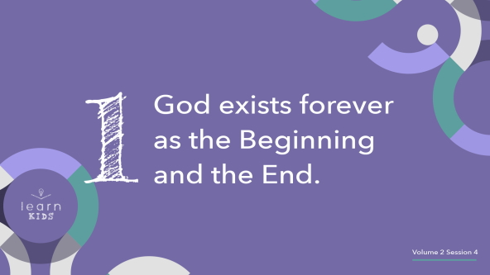

The concept of forever is really mind-boggling when you think about it. Let’s try this. I want everyone to close your eyes and try to think of the very first thing you remember.

• *Wait for the kids to close their eyes*.

Now, open your eyes. You probably thought of a memory when you were little. That was just a few years ago for most of you. My first memory is a lot older than that.

• *Optional: Briefly share your first memory with kids*.

God has existed forever. How long is forever? We don’t know because there is no beginning to forever. We can’t imagine it or explain it. Now, close your eyes and imagine what it was like before God created anything.

• *Give kids a few moments to reflect*.

Open your eyes. What did you see? *(Allow responses.)* Genesis 1:2 says everything was empty and dark. We may think about the beginning as when God created the heavens and the earth in Genesis, but God existed even before that.

He is the beginning and the end of everything. Obviously, God has been around a really long time. Best of all, He isn’t going anywhere. He existed before everything and everyone. That’s pretty cool to think about.

**2. God is the same today as He has always been**.

• *Show the* ***Teaching Point 2 Slide***.

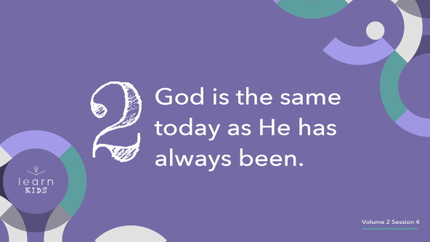

Let’s take that concept to another level. Not only has God been around forever, but He is the same God as He always has been. He hasn’t changed or morphed into something different over thousands of years. When God appeared to Moses in the burning bush, Moses asked Him a question. Moses asked what to say to the people of Israel if they asked for God’s name. Can anyone remember what that was? *(Allow responses.)*

One name that God told Moses is, “I am.” This name may be confusing to you. It may have been to Moses as well. There is a very good reason God gave this name to Moses. The name “I am” let God’s people know that He was the eternal God. Before the beginning of the world, God, the “I am,” was there. Forever in the future, God, the “I am,” will be there. This name lets us know that no matter where we are or how old we are, God, the “I am,” will be there for us.

God was the “I am” in Moses’s time. God, the “I am,” is still with His people today. We know this is true because [Malachi 3:6](https://ref.ly/logosref/Bible.Mal3.6) says, “I am the Lord, and I do not change.” Why is that so important for us to know? If God did something awesome in Bible times, He can still do it today. Let’s think of some of the most incredible stories in the Bible together. What are your favorites, and what do they show us about God? *(Allow two or three responses.)*

• *After each response tell the kids, “We follow the same God today.”*

We need to remember that we follow the same God who did all those incredible things we read about in our Bible. He is still working and doing incredible things for people today.

**3. God desires to connect with us individually**.

• *Show the* ***Teaching Point 3 Slide***.

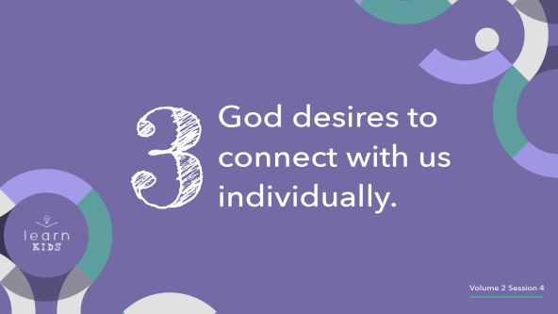

• *You will use the white board/poster board and marker in this segment*.

Sometimes, what happens in Bible stories seem different from what happens today. But, there’s a lot that’s the same. In Old Testament times, God sometimes used special leaders like Moses to connect with His people. Today, God uses pastors and church leaders to help us, but God doesn’t just use other people to talk to us.

In today’s story, we saw that God talked directly to Moses. In lots of other Bible stories, we can see that, too. Since creation, God has wanted to connect with each of us. Our eternal God is the same God He’s always been, and He still wants to talk directly to you. Does it surprise you that God wants to talk to you? *(Allow responses.)*

There’s one thing that pulls us away from being close to God. It’s called sin. Sin is when you do something wrong that you know you shouldn’t do. Have you ever sinned? *(Group response)* Yes, we all have sinned. Let’s name some of the sins we see happening today.

• *On the white board or poster board, write down the sins the kids mention*.

Something happened at the beginning of the New Testament that changed everything for all of us. What happened? *(Allow responses.)* That’s right! Jesus came to earth and died on the Cross, taking all our sins on Him.

• *Draw a cross on top of the list of sins*.

Jesus was the ultimate sacrifice that paid for all our sins. He made it even easier to connect with God. He took care of our sin problem. Because of Jesus, we can get even closer to God. We can come into His presence anytime we want.

• *Erase all the sins and leave a clean white board or turn the poster board to the other side*.

We don’t have to be at church or talk to our pastor to spend time with God. God wants to connect with us so much that He sent Jesus to die for us.

**Prayer and Response**

*Consider playing a worship song softly in the background while kids pray*.

Jesus died and rose again, and that lets each one of us have a closer relationship with God.

• *Optional: Salvation opportunity. Invite kids to ask Jesus to forgive their sins*.

Jesus didn’t die just so you could pray one prayer and move on. God wants to be with you. He wants to connect with you every day. Remember, God is always with you. You can spend time with Him anytime you want. You don’t have to sit in a waiting room, schedule an appointment, or leave Him a message. God is available anytime.

Let’s take a few minutes right now to spend with Him in prayer and thank Him for being with us. Find a spot in the room where you can get away from everyone else and any distractions to spend some time with God.

• *Allow kids to find a space to pray for a few minutes*.

**Prayer**

• *Optional: Have the kids repeat phrases of the prayer after you*.

|  |
| --- |
| Dear God, we love You. Thank You for sending Your Son, Jesus, to die for us. Thank You for not only being the God of Moses but also for being our God and our Best Friend forever. Thank You for always being there. Amen. |

**Faith Verse**

God has been around so much longer than all of us, and He knows what it was like before anything ever existed. It makes a lot of sense that He would think differently and do things differently from us. Let’s take another look at our Faith Verse.

• *Play* ***Faith Verse Video***.

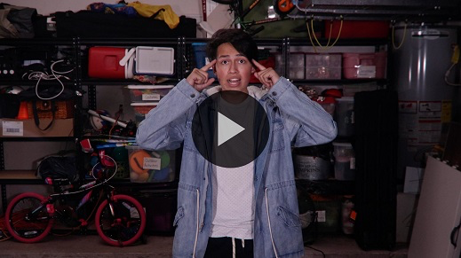

[Isaiah 55:8](https://ref.ly/logosref/Bible.Is55.8) (NLT)

“My thoughts are nothing like your thoughts,” says the Lord. “And my ways are far beyond anything you could imagine.”

**Faith Fact**

God is thinking about us. He is with us all the time even when it may not feel that way to us. Our Faith Fact helps us to remember that.

• *Show the* ***Faith Fact Slide***.



Say it with me. **My God is always with me.** I hope you’ve learned something new about God your Father. Even more than that, I hope you want to know even more about Him.

• *Dismiss kids to Small Group time or to go home if your group time ends here*.

**Small Group**

**30 Minutes**

*This section can be done in conjunction with the large group or on its own if you do small groups with your kids. During Small Group time, the goal is to connect the kids with the Word of God and to each other. All activities are led by the small group leader.*

**Group Connection**

**Always Together**

God is always with us even though we can’t see Him. This is an amazing truth that we can remember when we’re feeling lonely or like no one is there for us. We can’t lose God or leave Him behind. He is always right here with us, and He wants us to be with Him, allowing Him to lead us.

Our game will help us remember that. It’s called Always Together. The leader will lead the way and everyone in the group must follow in a line. You’ll do anything and everything the leader does, making sure you always stay together. Let’s give it a try.

• *Choose one kid to be the first leader*.

• *Have everyone stand up and form a line behind the leader. Leave some room between each kid*.

• *Encourage the leader to do a variety of motions and movements. They can make hand gestures, skip, march, jog, etc. Have fun with it!*

• *After a short time, choose a new leader. Keep playing for as long as you like, allowing every kid in your group to be leader if you have time*.

Good leading! Isn’t it amazing that the entire time we played that game, God was right here with us? We can’t see Him and don’t always feel His presence, but that doesn’t change what He promised in the Bible. **My God is always with me**.

**Learn about It**

|  |
| --- |
| ***You Will Need***   * *Bibles for kids in your group to share*   *No prep needed for this activity.* |

**Scripture Search:** [**Revelation 1:8**](https://ref.ly/logosref/Bible.Re1.8)**;** [**Isaiah 46:9–10**](https://ref.ly/logosref/Bible.Is46.9-10)**;** [**Psalm 90:1–2**](https://ref.ly/logosref/Bible.Ps90.1-2)**;** [**1 Timothy 1:17**](https://ref.ly/logosref/Bible.1Ti1.17)

Let’s dig deeper into God’s Word and see what else He has to say to us. As we find and read each of these verses, let’s consider: What does this Scripture mean for our life today?

• *Give each kid a Bible and search for one or more of the Scriptures as a group together (as time allows). When everyone has found the Scripture, have one of the kids read it. Then, answer the questions about it*.

• *Pair kids who need additional help with older kids or start simple and look up the session’s Bible story Scripture:* [*Exodus 3:1–15*](https://ref.ly/logosref/Bible.Ex3.1-15)*. Kids will get better at finding Scriptures the more they practice*.

• *Optional: Make this a competition to see who can find the Scripture first*.

**Bible Reading Tip**

Here’s a Bible tip to remember. When you’re reading about people in the Bible, try to put yourself in their shoes. For example, close your eyes and imagine what it would have been like to see a burning bush and hear the voice of God like Moses did. The Bible is full of true stories that happened to real people just like you and me. Allow the stories to come to life in a new way each time you read them.

**Challenge**

We know that God is always with us, so let’s take advantage of that this week. Make it a goal to talk to God at least five different times during the day each day this week. Five may sound like a big number, but you can do it. They don’t have to be super long prayers. You only need to take a moment to connect with God in some way.

For example, you could be eating lunch and thank Him for providing your food, or you could be outside playing and thank Him for all of the amazing things He created. Look for things to thank God for all day long, and you will easily find them.

**Faith Fact**

Finding out more about God is a reminder to me of our Faith Fact. Say it with me: **My God is always with me.** Fold your hands and bow your head like you’re praying and say it again. **My God is always with me.** Now, raise your hands and shout it. **My God is always with me**.

**Group Discussion**

*Feel free to use all or just a few questions as a jumping-off place for good discussion. Questions marked with * are designed for more conversation. Adjust the questions based on the age or maturity of your group. Typically, older kids will be able to dive a little deeper than younger ones*.

**Questions**

• *If small group activities are not immediately following Large Group time, you may want to read the Bible story passage before this discussion*.

What was Moses doing when the angel of the Lord appeared to him?

How did the angel of the Lord appear to Moses?

What did God tell Moses He was sending him to do?

What name did God say to tell the people of Israel if they asked what His name is?

* How would you have reacted to God speaking to you from a burning bush?

* Would you rather live now or in the Bible times? Why?

* What’s the best thing about God always being with you?

* How could it be a bad thing if God wasn’t always with you?

**Prayer Requests**

*Finish group discussion by sharing prayer requests and praise reports. Keep track of your small group’s prayer requests and review them each time you meet*.

**Prayer**

*Have kids pray for each other’s prayer requests*.

**Faith Verse Review**

|  |
| --- |
| ***You Will Need***   * *Timer* * *Small prize, for fastest kid*   *No prep needed for this activity.* |

Our Faith Verse is [Isaiah 55:8](https://ref.ly/logosref/Bible.Is55.8). It reminds us that because God has existed forever, He thinks and does things differently from how we would. Let’s watch the Faith Verse video and do the actions for the verse together.

• *Show* ***Faith Verse Video***.



[Isaiah 55:8](https://ref.ly/logosref/Bible.Is55.8) (NLT)

“My thoughts are nothing like your thoughts,” says the Lord. “And my ways are far beyond anything you could imagine.”

**Faith Verse Fun**

**Speedy Verse**

Now, let’s see how fast we can say the verse as a group. We’ll go around our group and each one of us will say one word. I’ll time us to see how fast we can say it.

• *Begin the timer and say the verse*.

That was pretty good. Do you think we can go faster? *(Group response)* Let’s try it.

• *Time the kids as they say the verse*.

Who thinks you can say the verse faster than the group? *(Allow responses.)* If you’re up for the challenge, I’m going to time you to see just how fast you can say the Faith Verse from memory. If you say it the fastest, you’ll win a prize.

• *Time each kid when they say the verse. Give a prize to the kid who says the Faith Verse the fastest and correctly*.

**Activity Page**

**Holy Ground**

|  |
| --- |
| ***You Will Need***   * ***Small Group Activity Page****, one per kid* * *Markers or crayons*   ***Getting Ready***   * *Print copies of the* ***Small Group Activity Page****, one per kid.* |

At the beginning of our Bible story when Moses came close to the burning bush, what did God tell him to do? *(Allow responses.)* It seems a little unusual that God wanted Moses to take off his shoes. Why do you think God told him to do that? *(Allow responses.)*

This is a good reminder that church isn’t the only holy place we can be with God. Any time God is present, it’s a holy place, and we can worship Him. Let’s color this picture of Moses worshipping God to remember that.

• *Give each kid a copy of the* ***Small Group Activity Page*** *and markers or crayons. Let them complete the page*.

**Dismissal**

We’ve had an awesome time together learning more about God, our Father, today. Let’s close in prayer.

**Prayer**

|  |
| --- |
| *Dear God, thank You for always being with us. Help us to take moments throughout our day to connect with You and know You more. Amen.* |

**Faith Fact Recap**

• *Show the* ***Faith Fact Slide***.



One important thing I want you to remember from today is our Faith Fact. Let’s say it together one more time. **My God is always with me.** I’m so glad you came. I can’t wait to see you next time.

• *Send home the* ***Small Group Activity Page***.

• *Remind parents that there are* ***Family Devotions*** *available on the app to do with their kid*.

• *Tell everyone the date and time for the next session*.

.